Samantha Minchew

INFO 4670

Fall 2023

DATA ANALYSIS REPORT: Ramen Ratings

*Understaning Data Through Functions of Excel*

**THE IMPORTANCE OF UTILIZING DATA IN EXCEL:**

Being able to utilize Excel functions is mandatory for making data analyzing easier. Rather than doing self-calculations, understanding everything that Excel has to offer allows data to be properly handled at a timely and simplistic manner. It is vital to be able to utilize all Excel’s functions in a data science field. Understanding VLOOKUP and HLOOKUP, MIN and MAX, and finding the SUM in any data set allows a closer step to mastering Excel.

**UNDERSTANDING DATA:**

The data selected is exploring the reviews of different ramen types. “Each record in the dataset is a single ramen product review. Review numbers are contiguous: more recently reviewed ramen varieties have higher numbers (Bilogur 1).” The data items listed include ramen packages, bowls, cups, packs and trays. These different varieties are then categorized by country and rated out of five stars. “Stars indicate the ramen quality, as assessed by the reviewer, on a five-point scale (1).” Below lies the data set describing the ramen brand, the different varieties, styles, location, and ratings. It is listed in an order based off of popularity; however, throughout this assignment it will be adjusted by ratings and alphabetically through the use of Excel.

**FINDING THE SUM:**

If the desired goal was to identify the SUM amount of all ratings, the numerical amount would be configured by the Sigma shortcut feature. By selecting the required data boxes, the =SUM feature would automatically collect data from E2:E17 and calculate the sum number. In this case, that equaled 105.25.

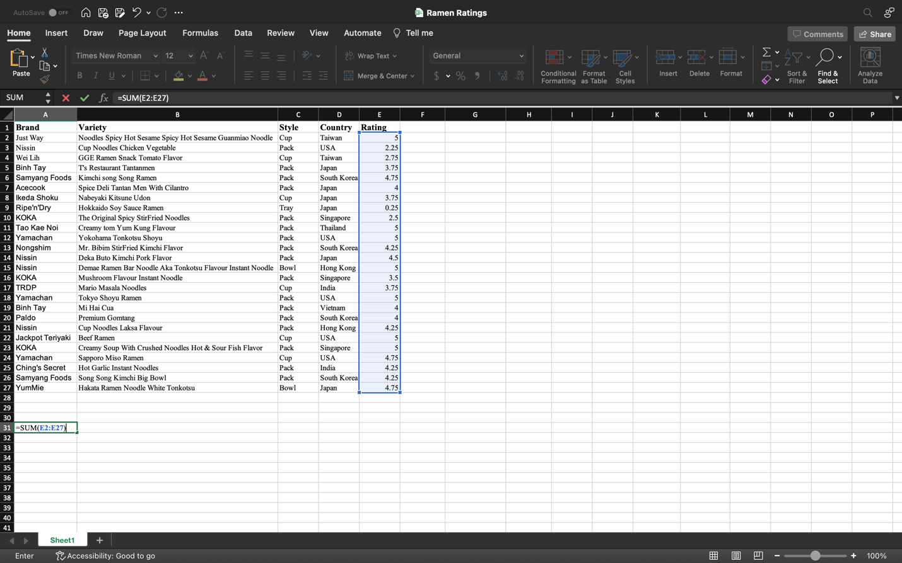

After selecting the SIGMA button and choosing the SUM shortcut, Excel will automatically turn the selected data boxes into the calculation after clicking ‘Enter.’ This will turn the function into a calculation collected by the selected numerical data selected in the data boxes.

Finding the SUM is important because data often requires quick addition of multiple numbers. The SUM function allows quick addition, as well as then being able to utilize other functions such as finding the average, product, and exponential differences.

As seen in the table below, it is possible to calculated the SUM by using the SIGMA feature and selecting the information desired to be calculated. After selecting the needed data, clicking the ‘enter’ button automatically allows the SUM to be calculated. As seen in the Excel function, =SUM (E2:E27) turns into 105.25

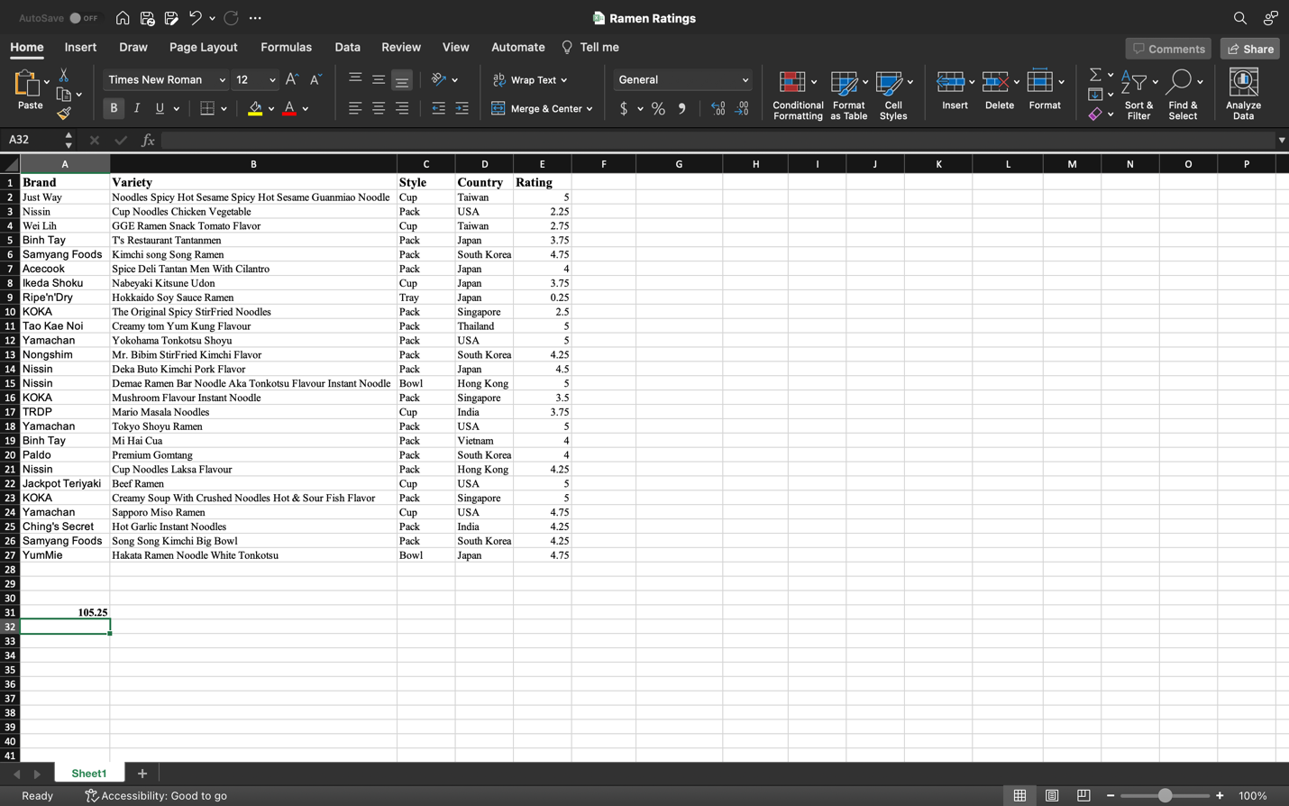

**FINDING THE AVERAGE:**

If the data set required finding the average, the SIGMA button would also be needed. Finding the average is important because it allows the use of comparing data sets to each other. Comparing data enables differences to be seen and utilized.

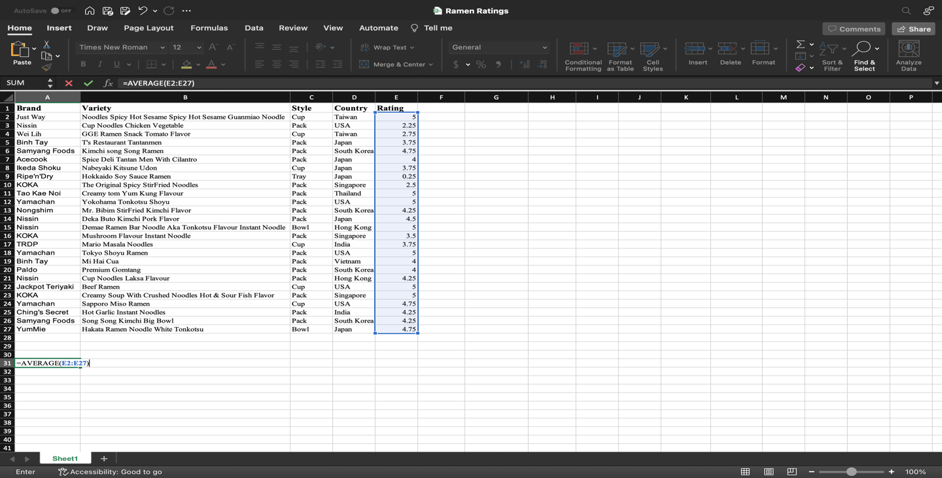

The average in this data set is configurated by selecting the SIGMA, selecting average, then highlighting the needed data set (as seen in blue). =AVERAGE(E2:E27) is calculated after clicking ‘enter’ to add and divide the numbers to find the exact average number in the data set. Finding the average is useful because data can be collected and compared to each other. Understanding the average in a data set allows the use of truly understanding data and the importance of data in regards to each other. In a sorts, it allows the ability to compare and contrast from each other which can later be used in decision making or gathering more information.

**FINDING THE MAX/MIN FUNCTIONS:**

The MAX/MIN functions are extremely important, specifically in this data set, because it categorizes the highest rated ramen in comparison to the lowest. This function could allow the data set to be organized in order of highest rating to lowest, or vice versa by understanding this function and learning how to calculate it.

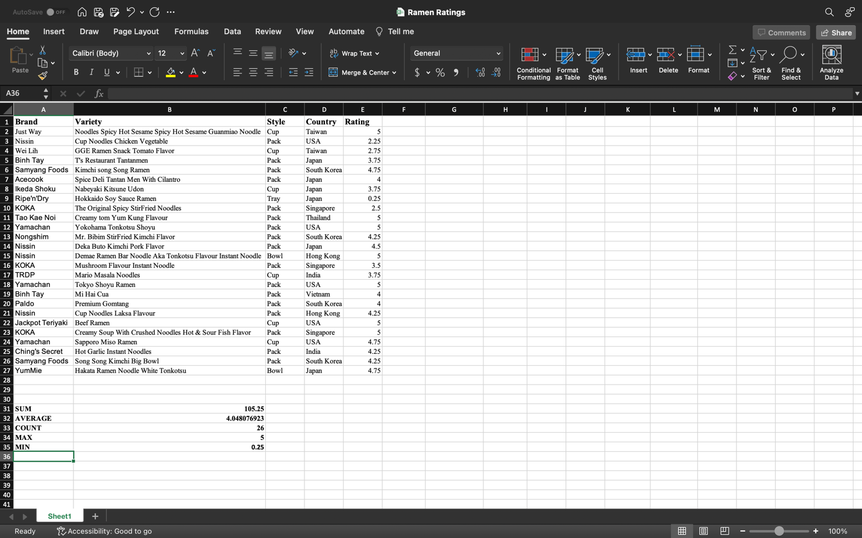

To find the MAX or MIN function, select SIGMA and choose which of the two functions prefferd. After selecting the data, this function will calculate the highest number or the lowest number out of the data set. Simply typing =MAX (E2:E27), then clicking ‘enter’ would find the highest number listed out of the data selected. The same goes for finding the lowest number. Enterting =MIN (E2:E27), then clicking ‘enter’ would have the same outcome as the MAX function, except it would find the lowest number listed in the set.

Finding the COUNT is useful for MAX/MIN function because it creates a visual for how many data sets are being compared and calculated. Like the MAX/MIN function, finding the COUNT is calculated by gathering the required data and using the COUNT function under SIGMA.

**VLOOKUP AND HLOOKUP:**

The data set is collected by ‘The Ramen Rater’ who categorizes ramen varieties into a popularity-based rating system using Excel’s VLOOKUP and HLOOKUP functions. The inspiration of this assignment is to create the highest valued ratings and categorize them into organized functions. Using HLOOKUP allows the data to compare values located in a row across the top table of data. This function allows Excel search for a certain value in a row in order to return a value from a different row in the same column. Similarly, VLOOKUP is finding values vertically instead of horizontally.

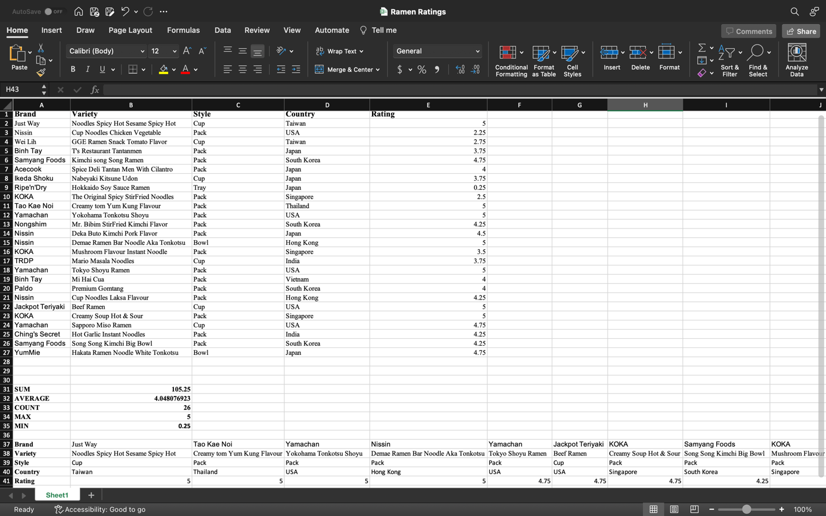

Compared to the original data set, it is possible to list it differently using HLOOKUP functions. It is also possible to change the organization by using different Excel functions to make it possible to list the data from MAX to MIN or alphabetically. Think of HLOOKUP and VLOOKUP functions as finding and analyzing data. This feature on Excel is handy because it is one of the most used lookup functions.

By using =HLOOKUP(“keyword”) or =VLOOKUP(“keyword”), it is possible to use a lookup function (in regard to other data), create a table array, or a row index column. These functions work together to find the range lookup from a data set. If this data had more numerical information, it could be utilized to compare and calculate the different sets in whichever column. However, since this data set only shows a singular numerical value it is difficult to utilize the HLOOKUP and VLOKUP functions to find the formula components for a value. These functions are extremely helpful to simply find the desired value, range for finding and returning the value, and the number of desired range that contains the value.

Citations

Bilogur, Aleksey. “Ramen Rating.” *Kaggle*, 11 Jan. 2018, www.kaggle.com/datasets/residentmario/ramen-ratings.

*PerfectXL: What is HLOOKUP in Excel // Excel Glossary // perfectxl*. PerfectXL. (2022, April 28). https://www.perfectxl.com/excel-glossary/how-to-use-hlookup-excel/